

**天燕纳米材料密度泛函计算软件**

**软件介绍：**

SHINE-DFT是基于密度泛函理论的量子力学程序，在投影缀加波的方法上，结合GPAW的均匀实空间网格表示电子波函数，显著的提高体系的伸缩性和计算的收敛性。有效原子轨道使用了更加精确的网格，大大提高计算的精度和灵活性。通过程序中的密度泛函理论（DFT）可以研究材料的基态性质，含时密度泛函理论（TDDFT）研究材料的激发态性质。

**计算对象：**

能够计算金属、半导体、氧化物或者多种结构混合的超晶格及其含有缺陷的原子等体系。

**计算功能：**

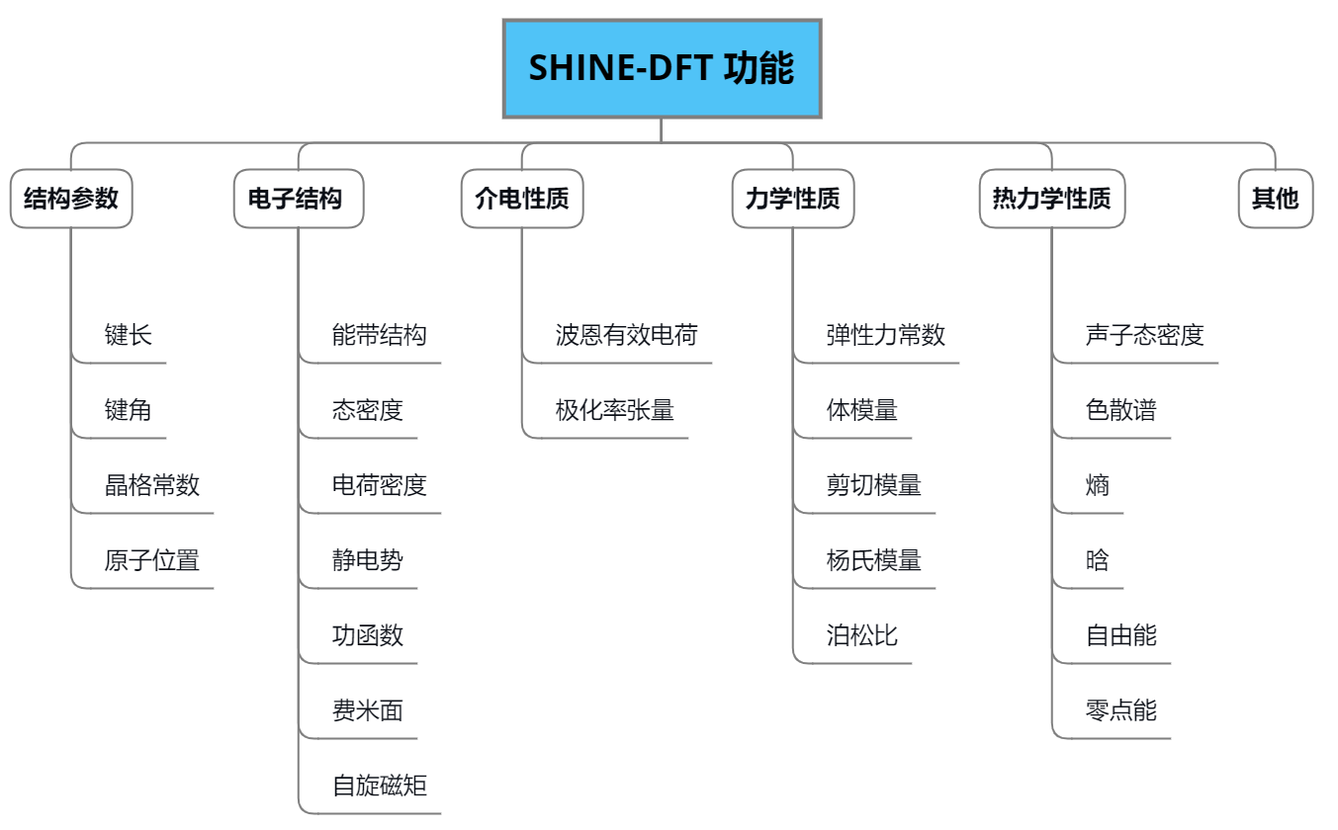

**计算流程：**

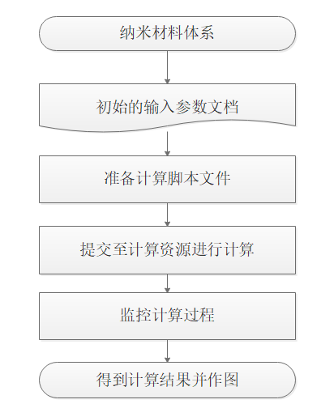

**输入输出：**



**应用案例：**

材料结构优化：

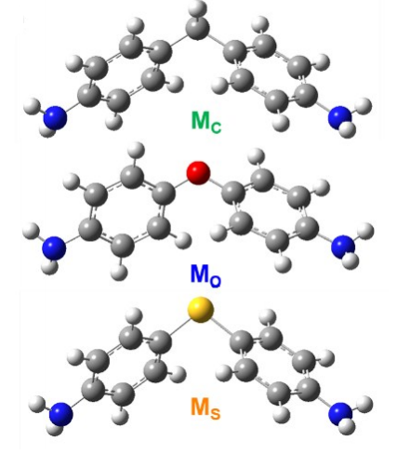

描述：通过DFT方法优化孤立的分子结构

分子轨道空间分布：

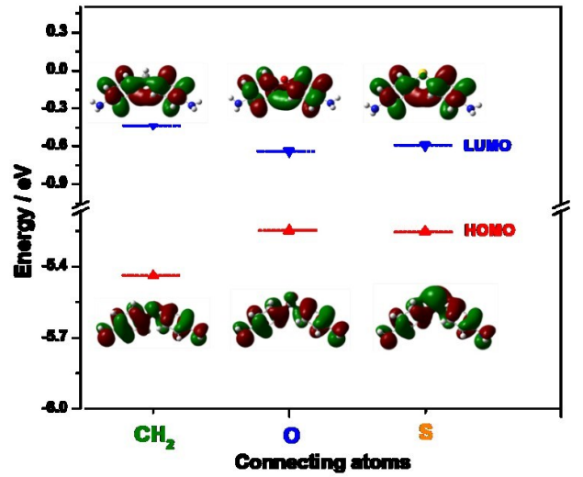

描述：分子轨道的HOMO-LUMO能级空间分布

吸收光谱性质：

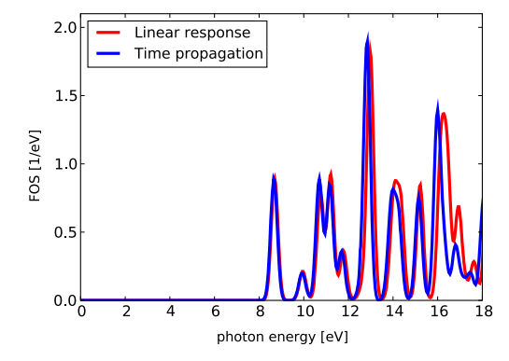

描述：通过时间传播和线性响应方法计算CH4分子的吸收光谱

光电子界面：

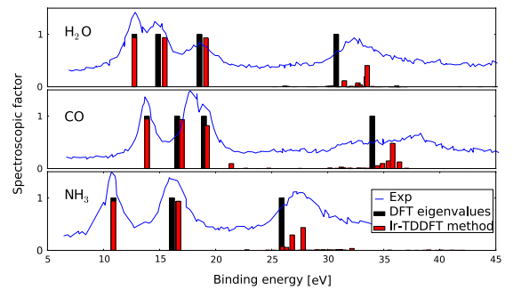

描述：光电子界面的计算对比：实验 & DFT方法 & TDDFT方法

输运性质：

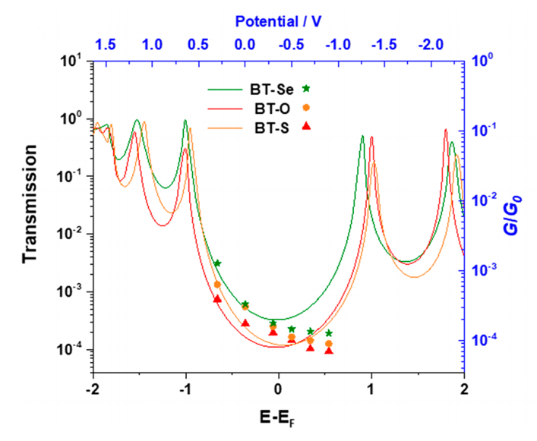

描述：门压控制下的电导和电子透射谱性质

**参考文献：**

[1] Chen J, Thygesen K S, Jacobsen K W. Ab initio nonequilibrium quantum transport and forces with the real-space projector augmented wave method[J]. Physical Review B, 2012, 85(15): 155140.

[2] Kohn W and Sham L J 1965 Self-consistent equations including exchange and correlation effects Phys. Rev. 140 A1133–8

[3] Runge E and Gross E K U 1984 Density-functional theory for time-dependent systems Phys. Rev. Lett. 52 997–1000

[4] Phillips J C and Kleinman L 1959 New method for calculating wavefunctions in crystals and molecules Phys. Rev. 116 287–94

[5] Kleinman L and Bylander D M 1982 Efficacious form for model pseudopotentials Phys. Rev. Lett. 48 1425–8

[6] Vanderbilt D 1990 Soft self-consistent pseudopotentials in a generalized eigenvalue formalism Phys. Rev. B 41 7892–5

[7] Bl¨ochl P E 1994 Projector augmented-wave method Phys. Rev. B 50 17953–79

[8] Wimmer E, Krakauer H, Weinert M and Freeman A J 1981 Full-potential self-consistent linearized-augmented-plane-wave method for calculating the electronic structure of molecules and surfaces: O2 molecule Phys. Rev. B 24 864–75

[9] Payne M C, Teter M P, Allan D C, Arias T A and Joannopoulos J D 1992 Iterative minimization techniques for ab initio total-energy calculations: molecular dynamics and conjugate gradients Rev. Mod. Phys. 64 1045–96

[10] Hehre W J, Stewart R F and Pople J A 1969 Self-consistent molecular-orbital methods. i. Use of Gaussian expansions of Slater-type atomic orbitals J. Chem. Phys. 51 2657–64

[11] Soler J M, Artacho E, Gale J D, Garc´ıa A, Junquera J, Ordej´on P and S´anchez-Portal D 2002 The SIESTA method for ab initio order-N materials simulation J. Phys.: Condens. Matter 14 2745

[12] Blum V, Gehrke R, Hanke F, Havu P, Havu V, Ren X, Reuter K and Scheffler M 2009 Ab initio molecular simulations with numeric atom-centered orbitals Comput. Phys. Commun. 180 2175–96

[13] Chelikowsky J R, Troullier N and Saad Y 1994 Finite-difference-pseudopotential method: electronic structure calculations without a basis Phys. Rev. Lett. 72 1240–3

[14] Beck T L 2000 Rev. Mod. Phys. 72 1041

[15] Junquera J, Paz O, S´ ´ anchez-Portal D and Artacho E 2001 Numerical atomic orbitals for linear-scaling calculations Phys. Rev. B 64 235111

[16] Briggs E L, Sullivan D J and Bernholc J 1996 Real-space multigrid based approach to large scale electronic structure calculations Phys. Rev. B 54 14362–75

[17] Enkovaara J E, Rostgaard C, Mortensen J J, et al. Electronic structure calculations with GPAW: a real-space implementation of the projector augmented-wave method[J]. Journal of Physics: Condensed Matter, 2010, 22(25): 253202.

[18] Wang Y H, Huang H, Yu Z, et al. Modulating electron transport through single-molecule junctions by heteroatom substitution[J]. Journal of Materials Chemistry C, 2020, 8(20): 6826-6831.

[19] Huang J R, Huang H, Tao C P, et al. Controlling Contact Configuration of Carboxylic Acid-Based Molecular Junctions Through Side Group[J]. Nanoscale research letters, 2019, 14(1): 1-7.

[20] Wang Y H, Yan F, Li D F, et al. Enhanced Gating Performance of Single-Molecule Conductance by Heterocyclic Molecules[J]. The journal of physical chemistry letters, 12: 758-763.

[21] Huang B, Liu X, Yuan Y, et al. Controlling and observing sharp-valleyed quantum interference effect in single molecular junctions[J]. Journal of the American Chemical Society, 2018, 140(50): 17685-17690.

[22] Peng L L, Chen F, Hong Z W, et al. Precise tuning of single molecule conductance in an electrochemical environment[J]. Nanoscale, 2018, 10(15): 7026-7032.